# Style Guide

# Basic coding standard

The key word “MUST”, “MUST NOT”, “REQUIRED”, “SHALL”, “SHALL NOT”, “SHOULD”, “SHOULD NOT”, “RECOMMENDED”, “MAY” AND “OPTIONAL” in this document are to be interpreted as described in  [RFC 2119](http://www.ietf.org/rfc/rfc2119.txt).

# Overview

* Files MUST use only <?php and <?= tags.
* Files SHOULD *either* declare symbols (classes, functions, constants, etc.) *or* cause side-effects (e.g. generate output, change .ini settings, etc.) but SHOULD NOT do both.
* Class names MUST be declared in StudlyCaps.
* Class constants MUST be declared in all upper case with underscore separators.
* Method names MUST be declared in camelCase.

# Comments

* It is “RECOMMENDED” to use // in single line comments.
* Multi-line comments are “RECOMMENDED” delimited with / * ... * / or multiple //.
* You “SHOULD NOT” use #.

Example:

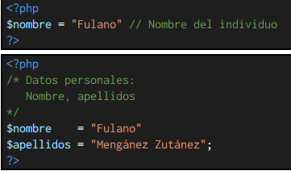

# Logical expressions

* It “SHOULD NOT” to compare the Boolean variables with the true or false values, it is advisable to use the variable directly or its negation.

# Functions

* Functions “MUST” be declared according to the "BSD / Allman" style. Example:

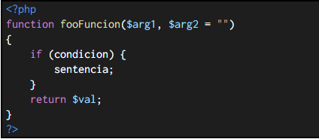

* The call to functions “MUST” be no spaces between the function name, the leading parenthesis, and the first argument. There “MUST” be spaces after commas that separate arguments. There should be no spaces between the last argument, the final parenthesis, and the semicolon. Example:

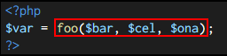

# Conditionals

* An if structure looks like the following. Note the placement of parentheses, spaces, and braces; and that else and elseif are on the same line as the closing brace from the earlier body. The keyword elseif SHOULD be used instead of else if so that all control keywords look like single words.

